**Approaches to create objects on kubernetes clusters.**

1. Declarative Approach
2. Imperative Approach

**1. Declarative Approach**

Creation of objects by writing a yaml/Json file is called the Declarative Approach. Kubectl is a CLI tool used to transfer the information from the api server to the kubernetes cluster. Kubectl command will act as the medium to give the data written in that particular yaml/json file to the api server of the kubernetes cluster. In real time we use a declarative approach to create kubernetes objects.

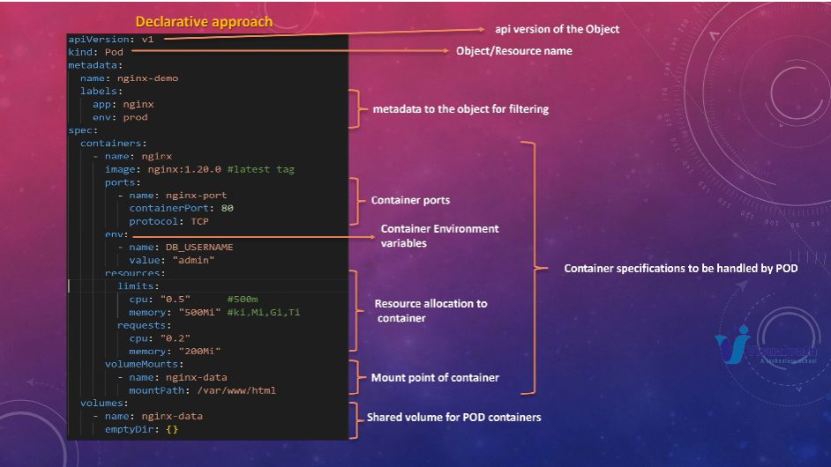

In this yaml file, we mention the api version of the object, what kind of object has to be created is written as value for kind, then in metadata we give the name of the object and labels to filter the objects. Next under the specifications section, we provide the names and details of containers, container environment, volumes, volumemounts and resources in a key value pair format.

First check whether the node is in Ready state or not before deploying a pod through any approach.

Kubectl get node -o wide command will give node status, age, version, ip address, image name, kernel version, container runtime through which it is created.



To create a pod using a declarative approach, first we need to create a yaml file using vim file editor.



We need to first verify which apiVersion is required to create a pod object, then define the type of object in the kind section and under metadata give the name of the pod and labels(optional) to filter pod easily.

Under the specification section define the containers with name(nginx-demo), image from which container needs to be created, container port on which container listens on, then volumeMounts with name of the volume and mountPath where that particular volume has to be mounted. The data which is present in the mountPath will be stored under shared volume.

Under volumes, provide the name of the volume same as above used in volumeMounts section of a container and emptyDir which stores the local cache or used to share data between different containers of a pod.

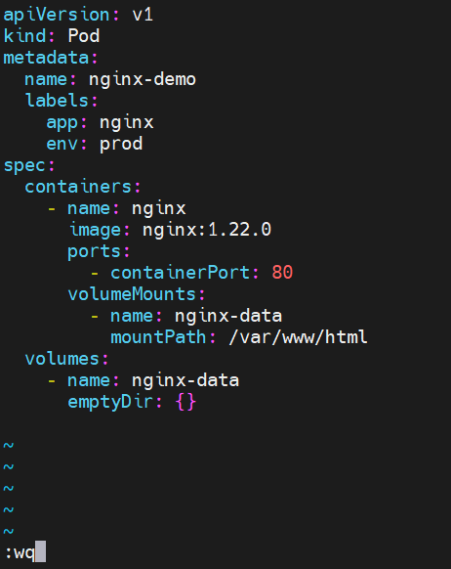

kubectl create -f file_name command is used to create a pod from the specified file.



Kubectl get pods command will list the number of pods.

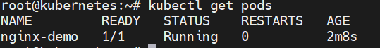

Kubectl get pod -o wide command will give the details of pod status, age, ip address and on which node it is created.



When we curl the ip address of the nginx-demo pod, we are able to see the default nginx page if it is successfully deployed.

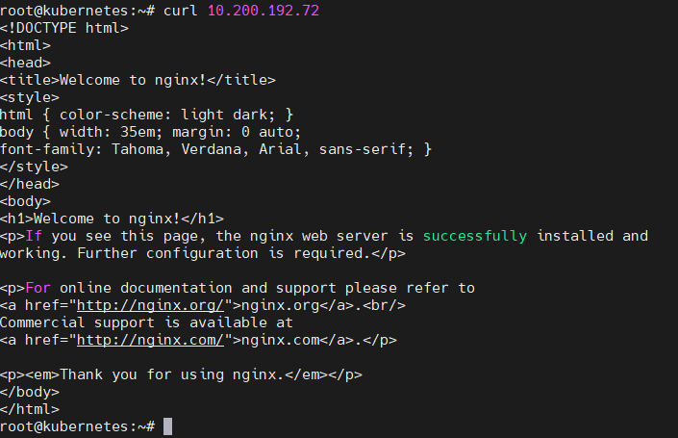

**2.Imperative Approach**

Executing cli commands to create an object in a kubernetes cluster is called an Imperative Approach. In real time we use this approach only when certain tasks or patch operations need to be performed depending on the situation.

First check whether the node is in Ready state or not before deploying a pod through any approach.

Kubectl get node -o wide command will give node status, age, version, ip address, image name, kernel version, container runtime through which it is created.



In the imperative approach, Kubectl run pod_name –image=image_name command will create the pod from the specified image.



Kubectl get pod -o wide command will give the details of pod status, age, ip address and on which node it is created.



When we curl the ip address of the nginx-demo pod, we are able to see the default nginx page if it is successfully deployed.

